CJ Email 1a: Welcome to the LUCI Family
Persona: Champion & Tech Implementor
Trigger: Contract Signed
Filter: Contact tagged as “Champion” or “Technical Implementor”
Subject Line: This is your official welcome to the LUCI family!
Preview text: Here's what happens next — and what we need from you before your kick-off call.

#FirstName#,
Welcome to the LUCI family, where we will support every system, every team, and every guest experience #PropertyName# delivers. We're excited to have you with us!
The engineers you'll meet in the coming weeks are integral to our partnership. These are the same people you'll work with throughout you entire LUCI engagement as an extension of your team. They're ready to get LUCI installed so you can:
- Give every team on your property a single, shared view of every A/V system and zone
- Remove the vendor management, processor conflicts, and workarounds your team is currently absorbing
- Turn your screens and A/V infrastructure into a tool for shaping the guest experience
- Build a technology foundation that gets more capable over time
What happens next
Our engagement will begin with a kick-off call, which you can schedule here. On that call, we'll:
- Confirm technical requirements and network infrastructure
- Walk through the implementation timeline
- Discuss your onsite install date
Before the kick-off call, we ask that you review our technical specifications document and fill out the form below. This information will ensure we can stick to our agreed timeline and get you up and running quicker.
→ [Pre-kick-off form]
From there, we’ll begin the installation process, which will look like this:
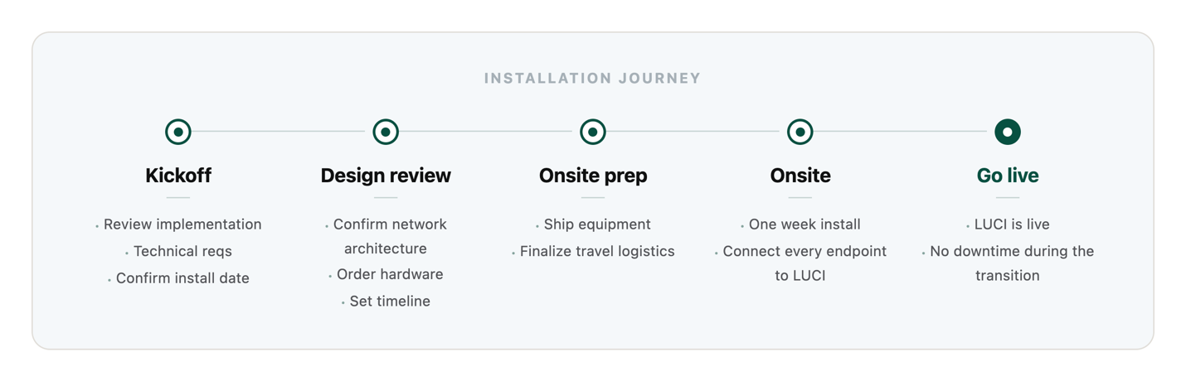
If you have any questions, please feel free to reach out, and I’ll be happy to help.
Welcome aboard.
Mike Epstein – CEO
C 702.326.5700 | O 833.333.5868
LUCIsystems.com Book Time with ME

